How to Create a Works Cited Page
What is a works cited page? A works cited page is a separate page at the end of your research paper or project. It is a list of resources (i.e. books, articles, etc.) that you have referenced in the body of your paper or project.
Our school subscribes to Noodle Tools, a program that will assist you in creating your works cited list. There are other free resources online that will help you create your citations. When using the databases for research, a citation is typically provided for you.
Remember:
- Label the page Works Cited (do not italicize the words Works Cited or put them in quotation marks) and center the words Works Cited at the top of the page.
- Double space all citations, but do not skip spaces between entries.
- Indent the second and subsequent lines of citations by 0.5 inches to create a hanging indent.
- Citations should be listed alphabetically by the first word in the citation (ignore first words such as The, A, An, etc.).
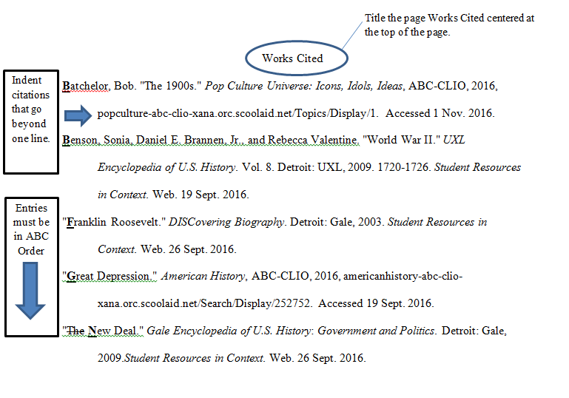
Example:

Noodle Tools—Step by Step Guide

HOW TO ACCESS NOODLE TOOLS:
- Visit noodletools.com
- Click LOGIN.
- On the right side of the screen, enter your @bmchsd.org email and click SIGN IN WITH GOOGLE.
  - ***If you have never used Noodle Tools before, select “Create New Account,” and then “I am a student or library patron.”
  - When asked for the school’s username & password, type in calhounhs/calhounhs
  - Follow the prompts to update and save your profile.

ONCE YOU HAVE LOGGED IN:
- "My Projects" page will be displayed.
- Click on the “+New Project” button.
- Select the citation style to MLA and the citation level to Advanced.
- In the description bar type in a name for your project and then click SUBMIT.

ADDING SOURCES TO YOUR WORKS CITED LIST:
- Open up the project you are working on
- Along the top of the page, select the SOURCES tab
- Click “+Create new citation”
- Follow the prompts to select the type of source you have used
- Fill in the blanks that appear making sure that spelling and capitalization are correct for each source.

HINT #1: For DATABSES, there is a QUICK CITE option where you can copy and paste a pre-formatted citation.

HINT #2: For book sources, you can enter the ISBN number (the barcode on the back of the book) and Noodle Tools will automatically fill in the resource information for you.

- Once you’ve entered the information for your source, click on “Submit.”

ONCE ALL SOURCES HAVE BEEN ADDED:

Click on “Print/Export” button. You may export the list to Google Docs and will be prompted for your Google login information.

